H.T No
Regulations:
A18

Sreenidhi Institute of Science and Technology
(An Autonomous Institution)
Code No: 7HC13 Date: 08-Oct-2020 (FN)

B.Tech II-Year I-Semester External Examination, October - 2020 (Supplementary)
TRANSFORM TECHNIQUES and NUMERICAL METHODS (eee and ece)

Time: 2 Hours Max.Marks:70

Note: a) No additional answer sheets will be provided.
b) All sub-parts of a question must be answered at one place only, otherwise it will not be valued.
c) Missing data can be assumed suitably.

ANSWER ANY FIVE QUESTIONS. EACH QUESTION CARRIES 14 MARKS.

1. | a) | Evaluate 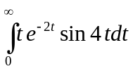 | [7M]
 | b) | Evaluate 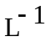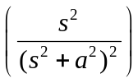 | [7M]
2. | a) | Evaluate Z transform of cosnθ and sinnθ. | [7M]
 | b) | Find Inverse Z transform of 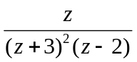 | [7M]
3. | a) | Solve the equation(y+z)p+(x+z)q=x+y | [7M]
 | b) | Solve the equation p²z²+q²=1 | [7M]
4. | a) | Using bisection method find the approximate root of the equation  x³-x-1=0 . | [7M]
 | b) | Find the approximate root of the equation xe^{x}=cosx using Regula-Falsi method. | [7M]
5. | a) | Find the missing values in the following table. | [7M]
  x | 0 | 5 | 10 | 15 | 20 | 25
  y | 6 | 10 | - | 17 | - | 31
 | b) | Fit a polynomial using Newton’s forward interpolation formula to the following data | [7M]
  x | 20 | 30 | 40 | 50 | 60 | 70 | 80
  y | 144 | 208 | 238 | 264 | 248 | 324 | 388
6. |  | Apply Range – Kutta method of 4th order find the solution of 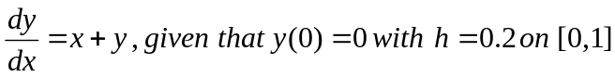. | [14M]
7. |  | Using Z- transforms, solve the difference equation u_{n+2}+2u_{n+1}+u_{n}=n with u₀=u₁=0. | [14M]
8. | a) | Solve y¹-y²=0 ,y(0)=1 at x=0.1and 0.2 by Euler’s method. | [7M]
 | b) | Find the Laplace transforms of 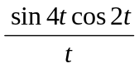. | [7M]

-- 00 -- 00 –

